Test Report

Project Name: Ivona Hagiu

Document Date: 2023.09.13

Table of Contents

Testing Scope 3

1.1. Test Environment 3

1.2. Testing Team 3

Test Results 4

1.3. Executed Test Cases 4

1.4. Exploratory testing 4

Defects 5

1.5. New defects 5

Performance testing 6

1.6. Performance testing 6

Conclusions 7

# Testing Scope

This project aims to test the following:

| Product/Feature | Testing Period | Tested Builds | Deloyment Date |
| --- | --- | --- | --- |
| Functional testing:  - Test user registration;  - Login;  - Account management;  - Product search;  - Shopping cart functionality (adding, updating, removing items);  - Checkout process (payment methods and order confirmation); | 25.08-10.09.2023 | V1. |  |
| Non-functional testing:  - Performance testing. | 10.09-12.09.2023 | V1. |  |

## Test Environment

| Test Environment | Software Details | Comments |
| --- | --- | --- |
| Production | Chrome 116.0.5845.141,  Windows 11 Home  22H2, Asus Notebook | Tools used: TestLink, Mantis, BlazeMeter, JMeter |
| Production | Safari, iOS, 16.5.1 |  |

## Testing Team

| Role | Name | Comments (e.g. test effort h) |
| --- | --- | --- |
| Software Tester | Ivona Hagiu | 50 h |

# Test Results

## Executed Test Cases

| Functionality | Total | Pass | Failed | Blocked | Not Run | Defects |
| --- | --- | --- | --- | --- | --- | --- |
| 1. Chrome/ Smoke test | 6 | 6 | 0 | 0 | 0 | 0 |
| 1. Chrome/Registration | 8 | 4 | 4 | 0 | 0 | 53939, 53940, 53941, 53942 |
| 1. Chrome/Login | 9 | 8 | 1 | 0 | 0 | 53943 |
| 1. Chrome/Account | 23 | 20 | 3 | 0 | 0 | 53944, 53945, 53946 |
| 1. Chrome/Search | 9 | 7 | 2 | 0 | 0 | 53947, 53948 |
| 1. Chrome/Shopping cart | 10 | 9 | 1 | 0 | 0 | 53949 |
| 1. Chrome/Checkout | 16 | 13 | 3 | 0 | 0 | 53950, 53951, 53952 |
| 1. Chrome/Payment | 10 | 10 | 0 | 0 | 0 |  |
| 1. Safari/Smoke test | 6 | 6 | 0 | 0 | 0 |  |
| 1. Safari/Registration | 7 | 4 | 3 | 0 | 0 | 53953, 53954, 53955 |
| 1. Safari/Login | 9 | 8 | 1 | 0 | 0 | 53956 |
| 1. Safari/Account | 23 | 20 | 3 | 0 | 0 | 53957, 53958, 53959 |
| 1. Safari/Search | 7 | 5 | 2 | 0 | 0 | 53960, 53961 |
| 1. Safari/Shopping Cart | 10 | 9 | 1 | 0 | 0 | 53962 |
| 1. Safari/Checkout | 16 | 13 | 3 | 0 | 0 | 53964, 53965 |
| 1. Safari/Payment | 10 | 0 | 0 | 0 | 0 |  |
| 1. Non-functional test cases | 4 | 3 | 1 | 0 | 0 |  |

## Exploratory testing

| Functionality | Defects |
| --- | --- |
| Registration | Registration functionality: Registration is possible with an invalid email. |
| Login | Login functionality: A placeholder should be visible on the field. |
| Account | Account: validation message displayed when logging out is missing. |
| Search | Search functionality: a counter doesn't exists. |
| Shopping cart | Shopping cart functionality: there is no limit to the number of products a user can buy. |
| Checkout | Checkout functionality: confirmation message about creating an account is missing. |
| Payment | - |

# Defects

## New defects

| Defect ID | Defect summary | Severity |
| --- | --- | --- |
| 53965 | Checkout functionality: confirmation message about creating an account is missing. | normal |
| 53964 | Checkout: 'Back to cart' button doesn't exist. | normal |
| 53963 | Checkout functionality: The format of the error message is improper. | minor |
| 53962 | Shopping cart functionality: there is no limit to the number of products a user can buy. | blocker |
| 53961 | Search functionality: error message is not displayed for a blank input. | minor |
| 53960 | Search functionality: a counter doesn't exists. | minor |
| 53959 | Account: validation message displayed when logging out is missing. | normal |
| 53958 | Account: 'delete' option is not an available option for an address. | minor |
| 53957 | Account: 'delete' option is not an available option for an order. | minor |
| 53956 | Login functionality: A placeholder should be visible on the field. | minor |
| 53955 | Registration functionality: A placeholder should be visible on the field. | normal |
| 53954 | Registration functionality: The format of the error message is improper. | normal |
| 53953 | Registration functionality: Registration is possible with an invalid email. | major |
| 53952 | Checkout functionality: confirmation message about creating an account is missing. | normal |
| 53951 | Checkout: 'Back to cart' button doesn't exist. | normal |
| 53950 | Checkout functionality: The format of the error message is improper. | minor |
| 53949 | Shopping cart functionality: there is no limit to the number of products a user can buy. | critical |
| 53948 | Search functionality: error message is not displayed for a blank input. | minor |
| 53947 | Search functionality: a counter doesn't exists. | minor |
| 53946 | Account: validation message displayed when logging out is missing. | normal |
| 53945 | Account: 'delete' option is not an available option for an address. | minor |
| 53944 | Account: 'delete' option is not an available option for an order. | minor |
| 53943 | Login functionality: A placeholder should be visible on the field. | minor |
| 53942 | Registration functionality: Keyboard tab button functionality is not working. | normal |
| 53941 | Registration functionality: A placeholder should be visible on the field. | normal |
| 53940 | Registration functionality: The format of the error message is improper. | normal |
| 53939 | Registration functionality: Registration is possible with an invalid email. | major |

## 

# Performance testing

## Performance testing

|  |  |
| --- | --- |
| Test Scenarios | Used tools |
| 1. Measure response time for 5 users. | Blazemeter, Jmeter |
| 1. Measure response time for 50 users. |  |
| 1. Measure response time for 500 users. |  |
| 1. Measure response time for 1000 users. |  |

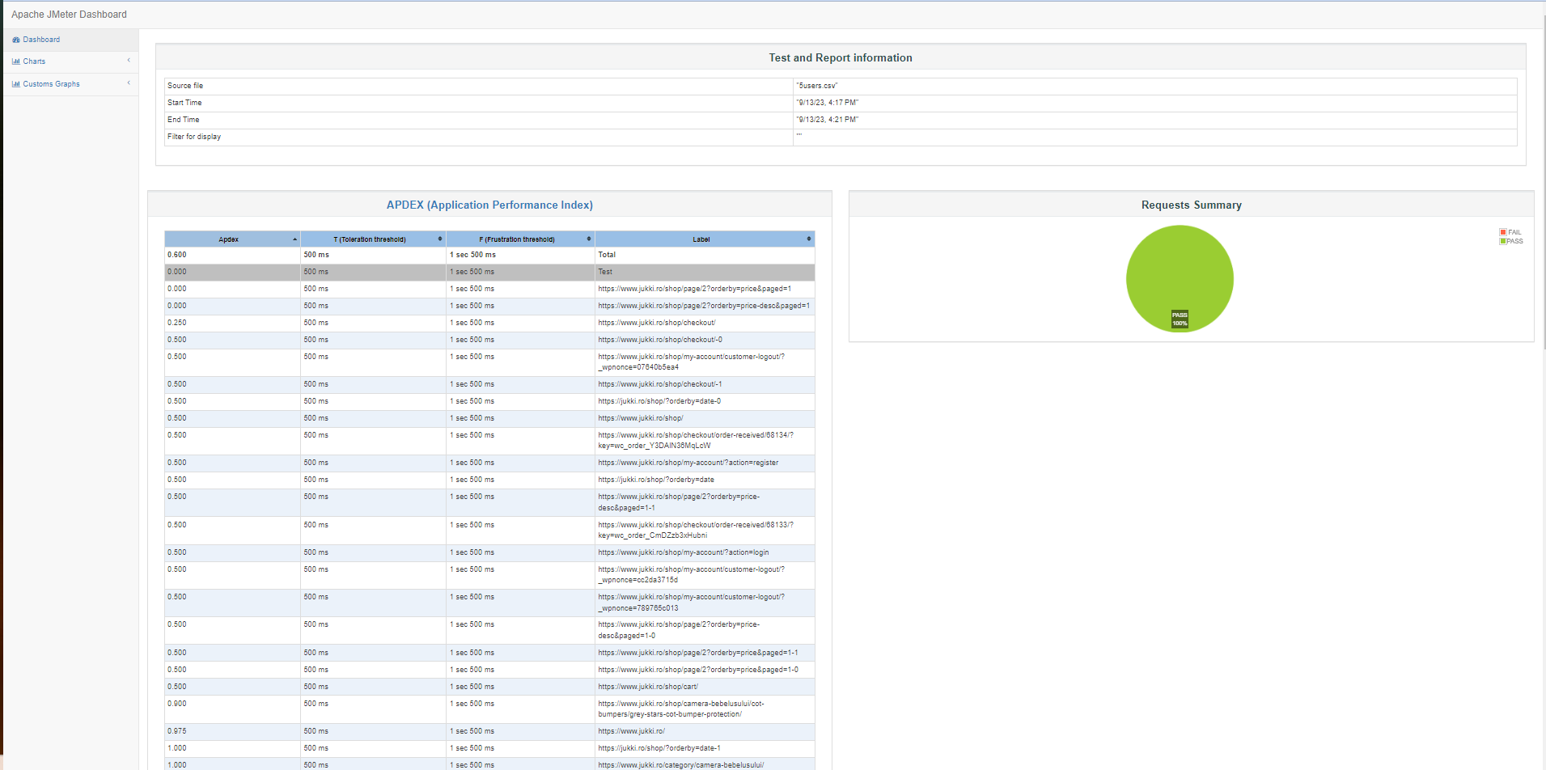

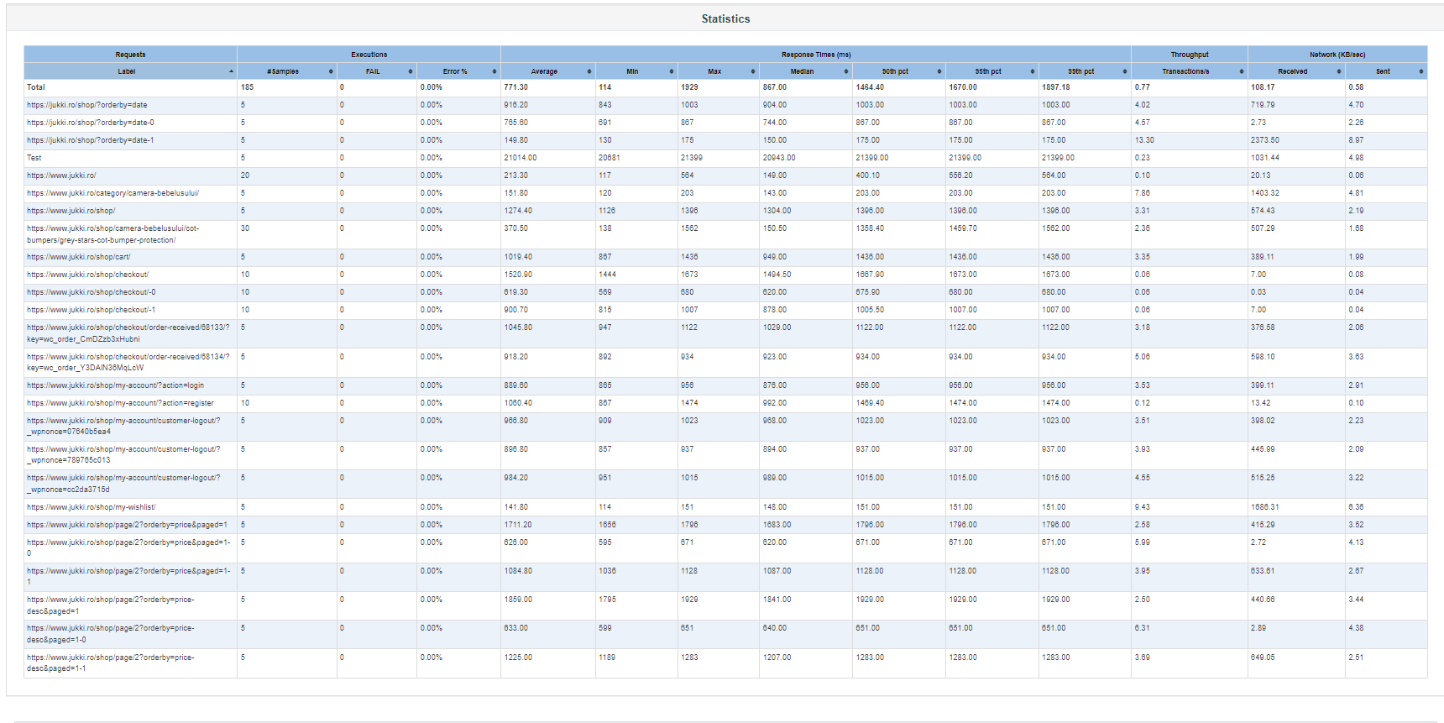

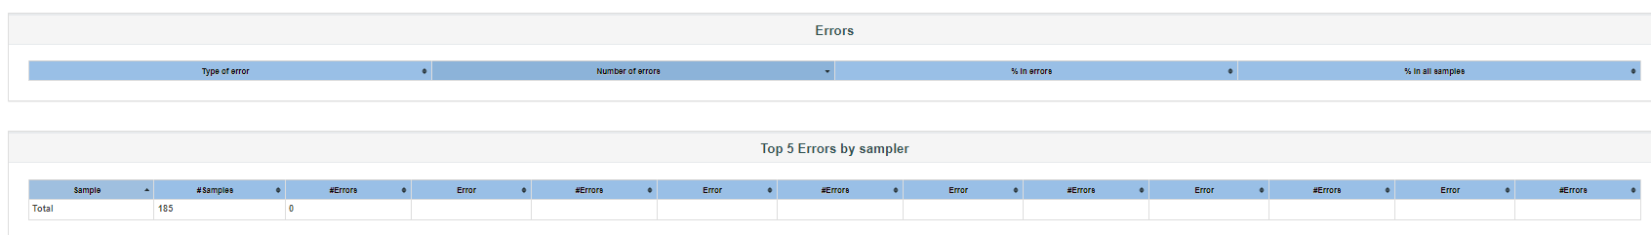

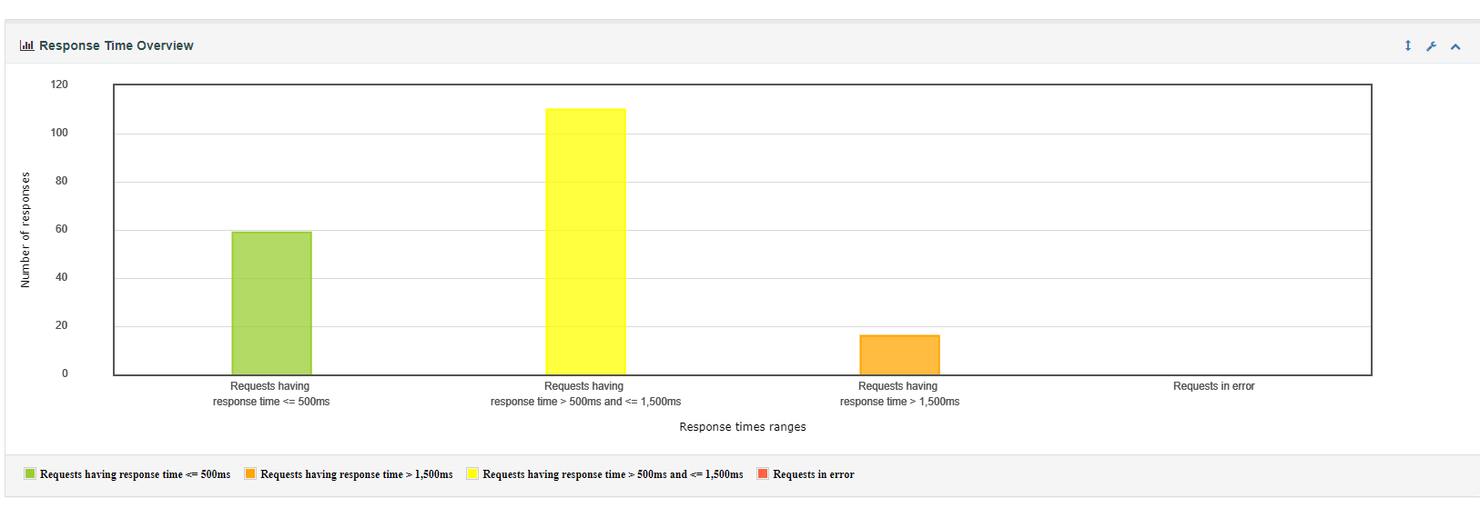

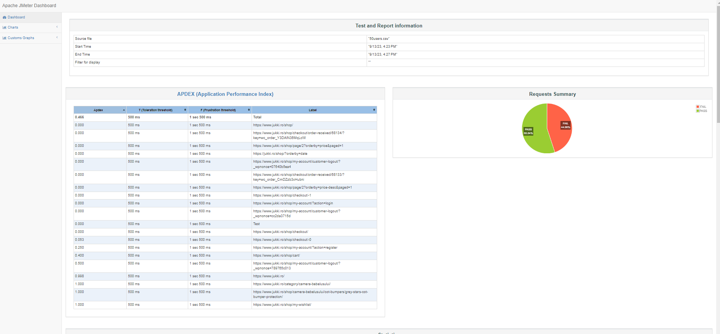

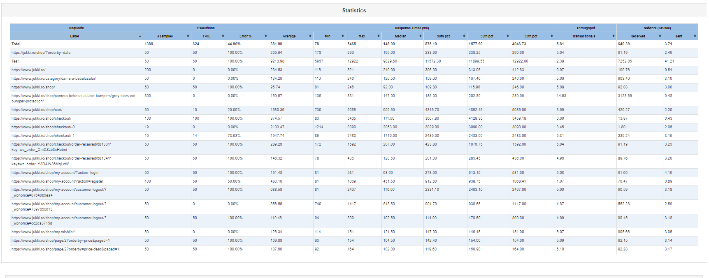

53


54



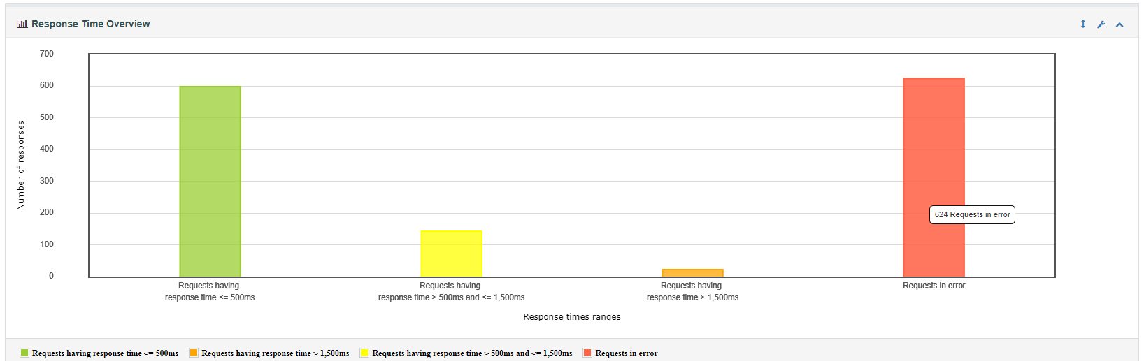

501


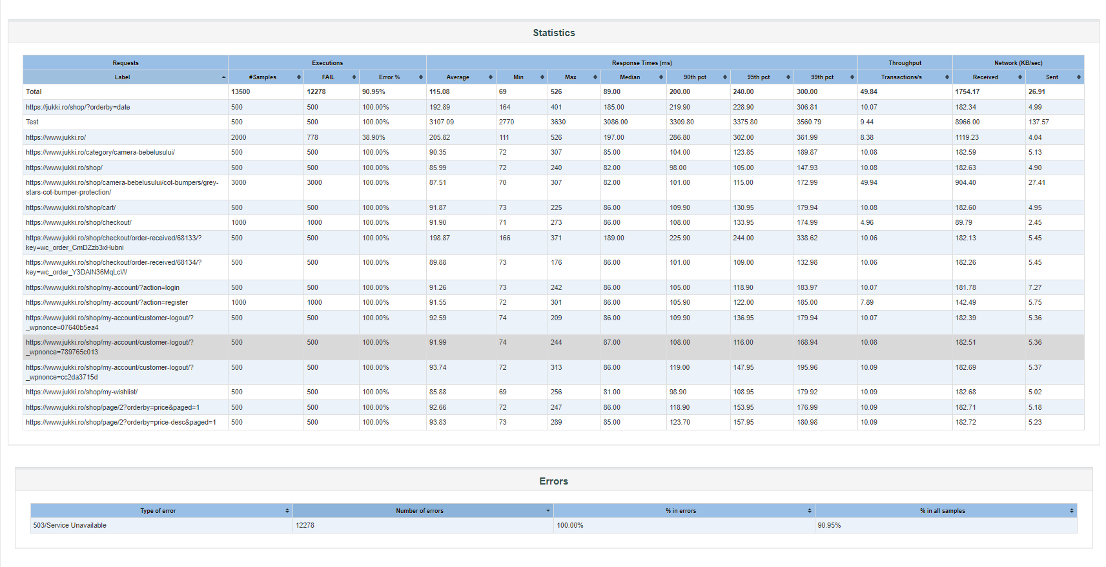

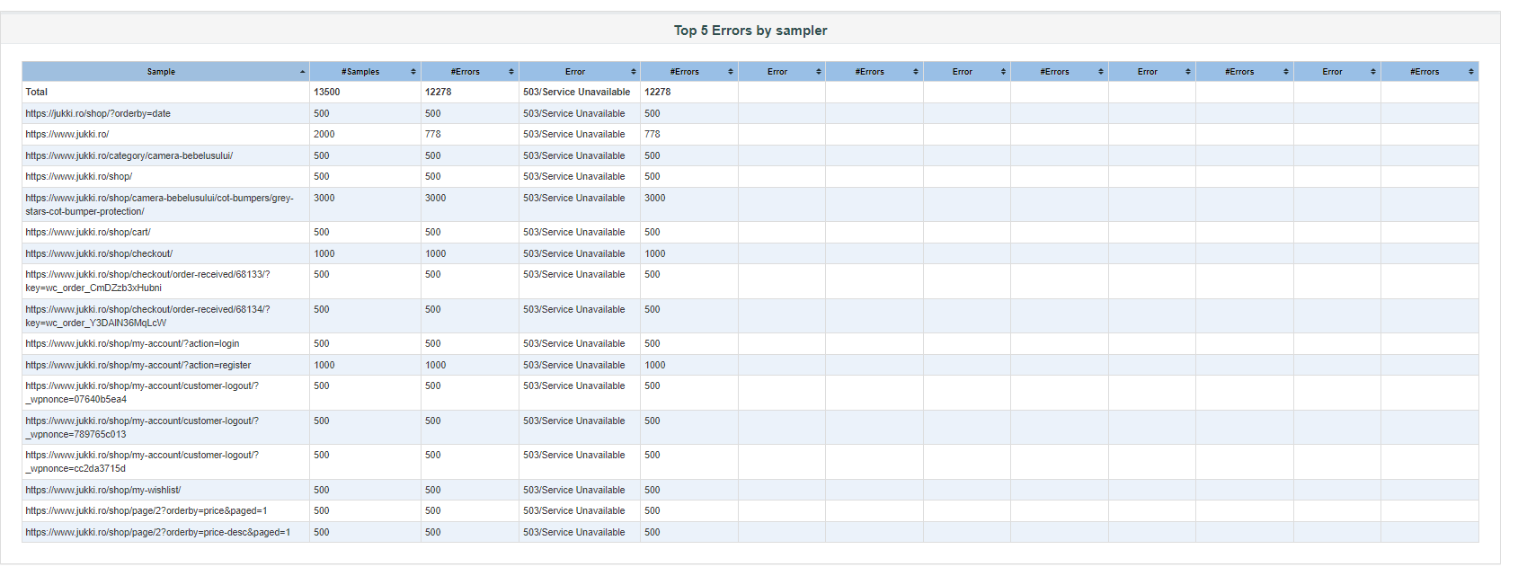

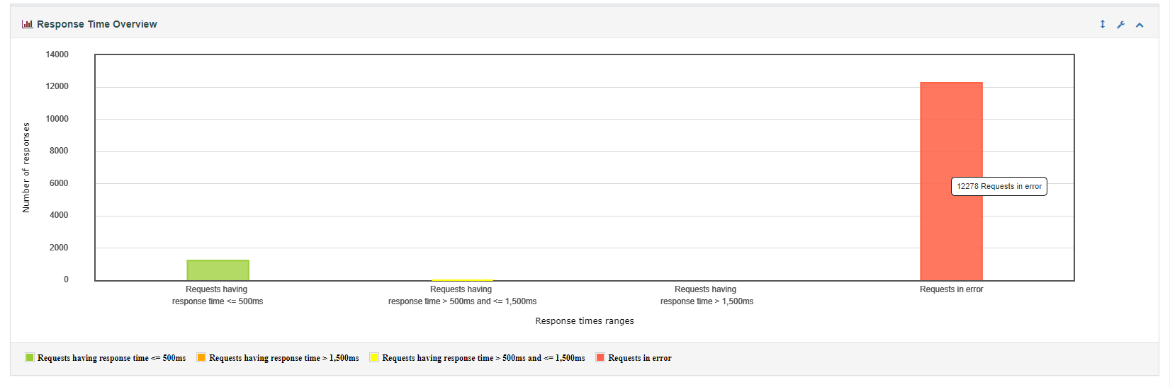

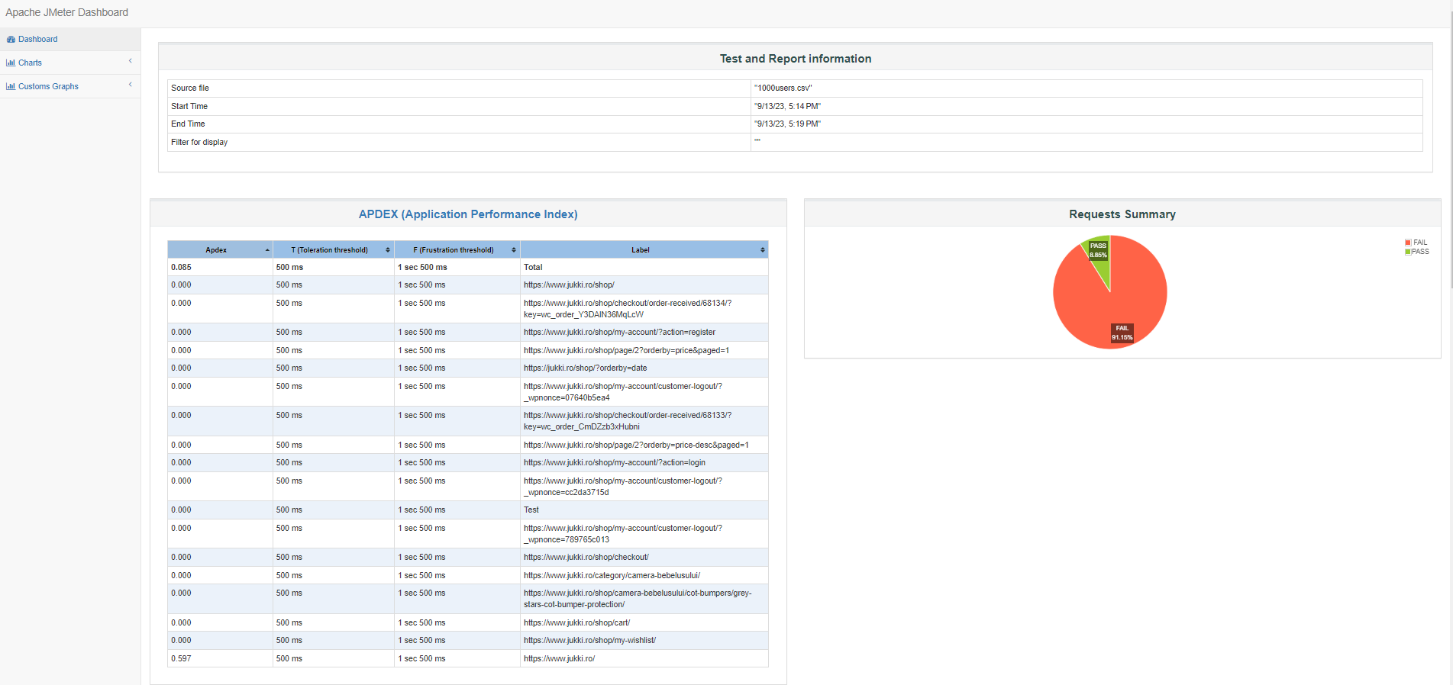

1002


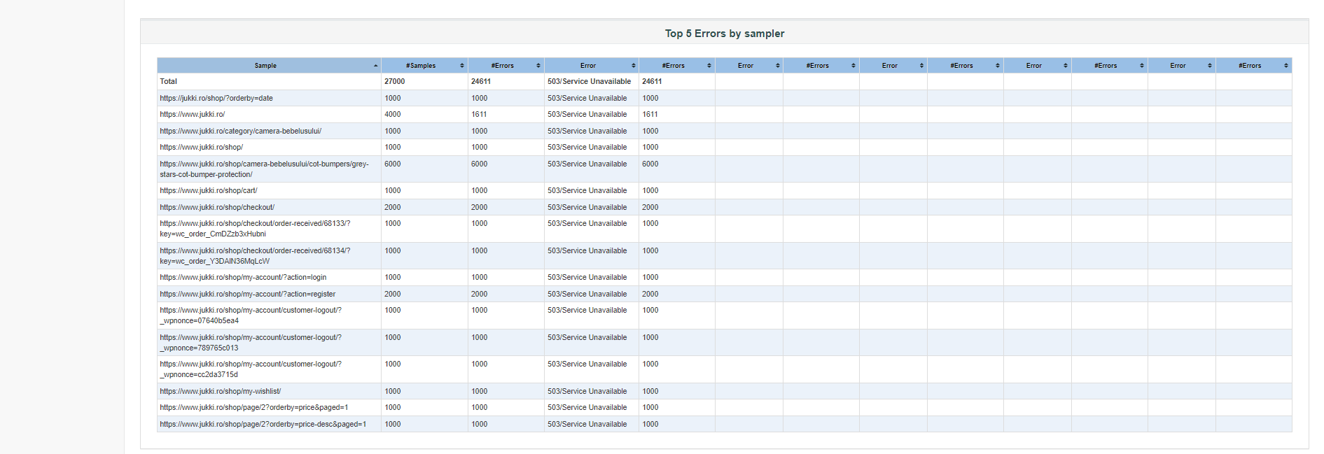

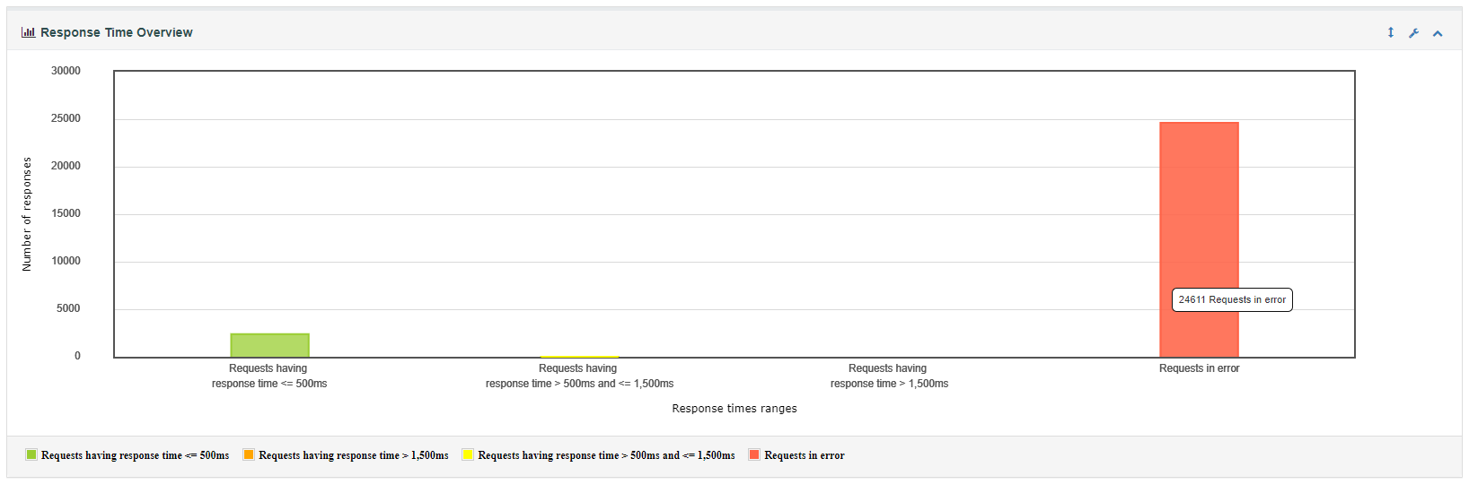

# Conclusions

Throughout the testing phase of this project I performed the following testing types:

1. Functional testing – was executed to validate that the system’s features operate as expected. The test cases covered a wide range of scenarios, including positive and negative tests and integration tests.
2. Performance testing – I subjected the system to various load conditions to asses the performance under different circumstances.
3. Exploratory testing – was conducted to uncover all the functional defects.

The [www.jukki.ro](http://www.jukki.ro) website was tested in one environment which is the production environment and on two web browsers: Chrome and Safari.

Throughout the testing phase, a total of 27 bugs were discovered, ranging in severity from minor to critical. Bugs identified:

* 2 critical bugs;
* 2 major bugs;
* 11 normal bugs;
* 12 minor bugs.

The application currently lacks a maximum limit on the number of products a user can purchase in a single transaction, which poses a critical risk to the system’s functionality.

Also, it’s important to note that out of the four load tests conducted (5 users, 50 users, 500 users, 1000 users) only one test passed, indicating significant performance issues.

Based on the testing results, I suggest postponing to go live with te app in its current state. The presence of a critical bug that allows unlimited product purchases, along with performance issues revealed during load testing, indicates that the app is not ready for production deployment.